Name: Noah Nguyen

R Lab 3: The normal distribution

Please answer all the Exercises and the questions from the “On Your Own” section. If you use any graphs or charts to justify your answer, please include them.

Exercise 1: Make a histogram of men’s heights and a histogram of women’s heights. How would you compare the various aspects of the two distributions? (Include plots.)
Histogram of men’s heights:
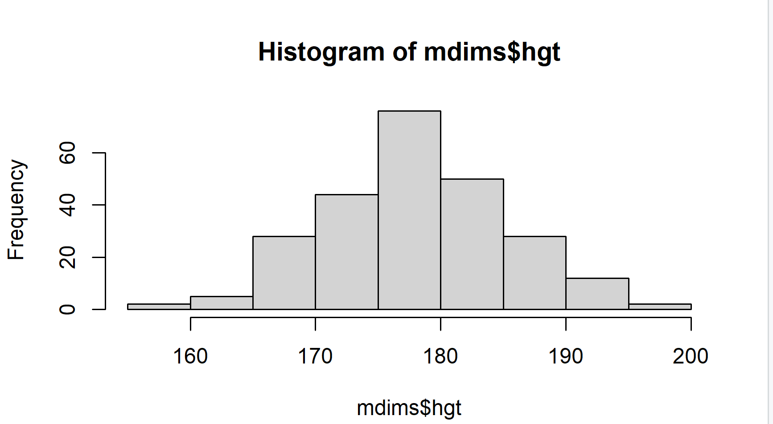
Histogram of women’s heights:
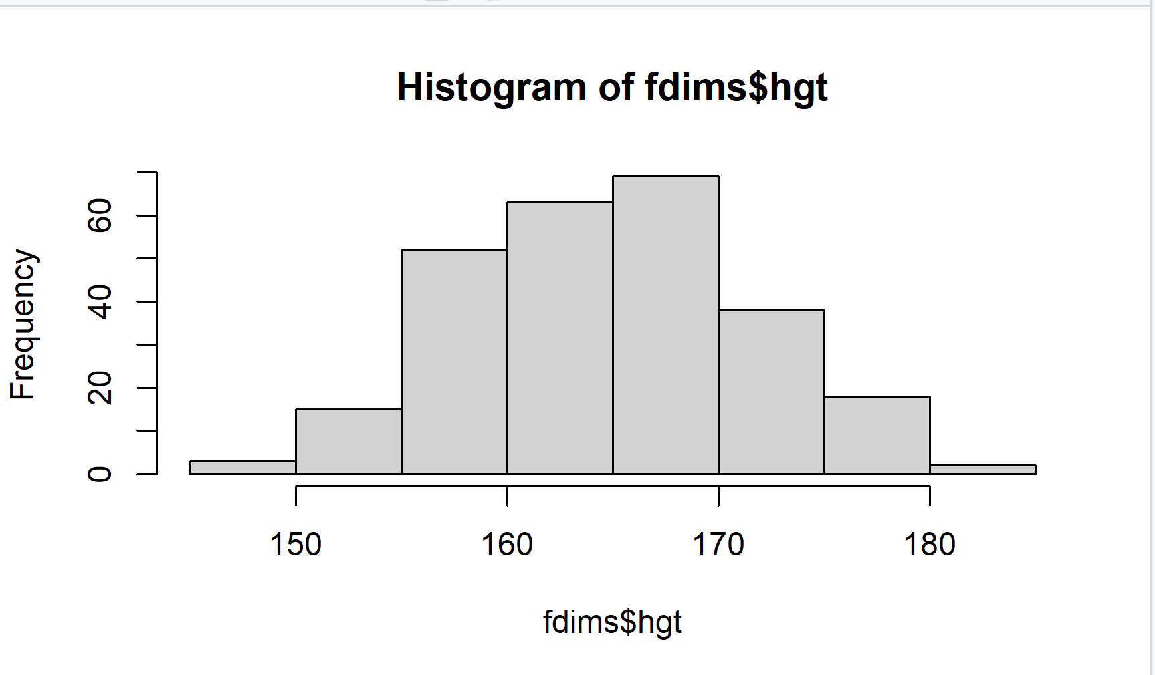
Both histograms indicate normal distribution. Men have a higher average height than women. The gaps are the same, which is 20.

Exercise 2: Redraw the histograms from Exercise 1 overlaid with the normal distribution with the same mean and standard deviation. Does it appear that the data follow a nearly normal distribution? Explain your answer. (Include plots.)

Histogram of women’s heights:
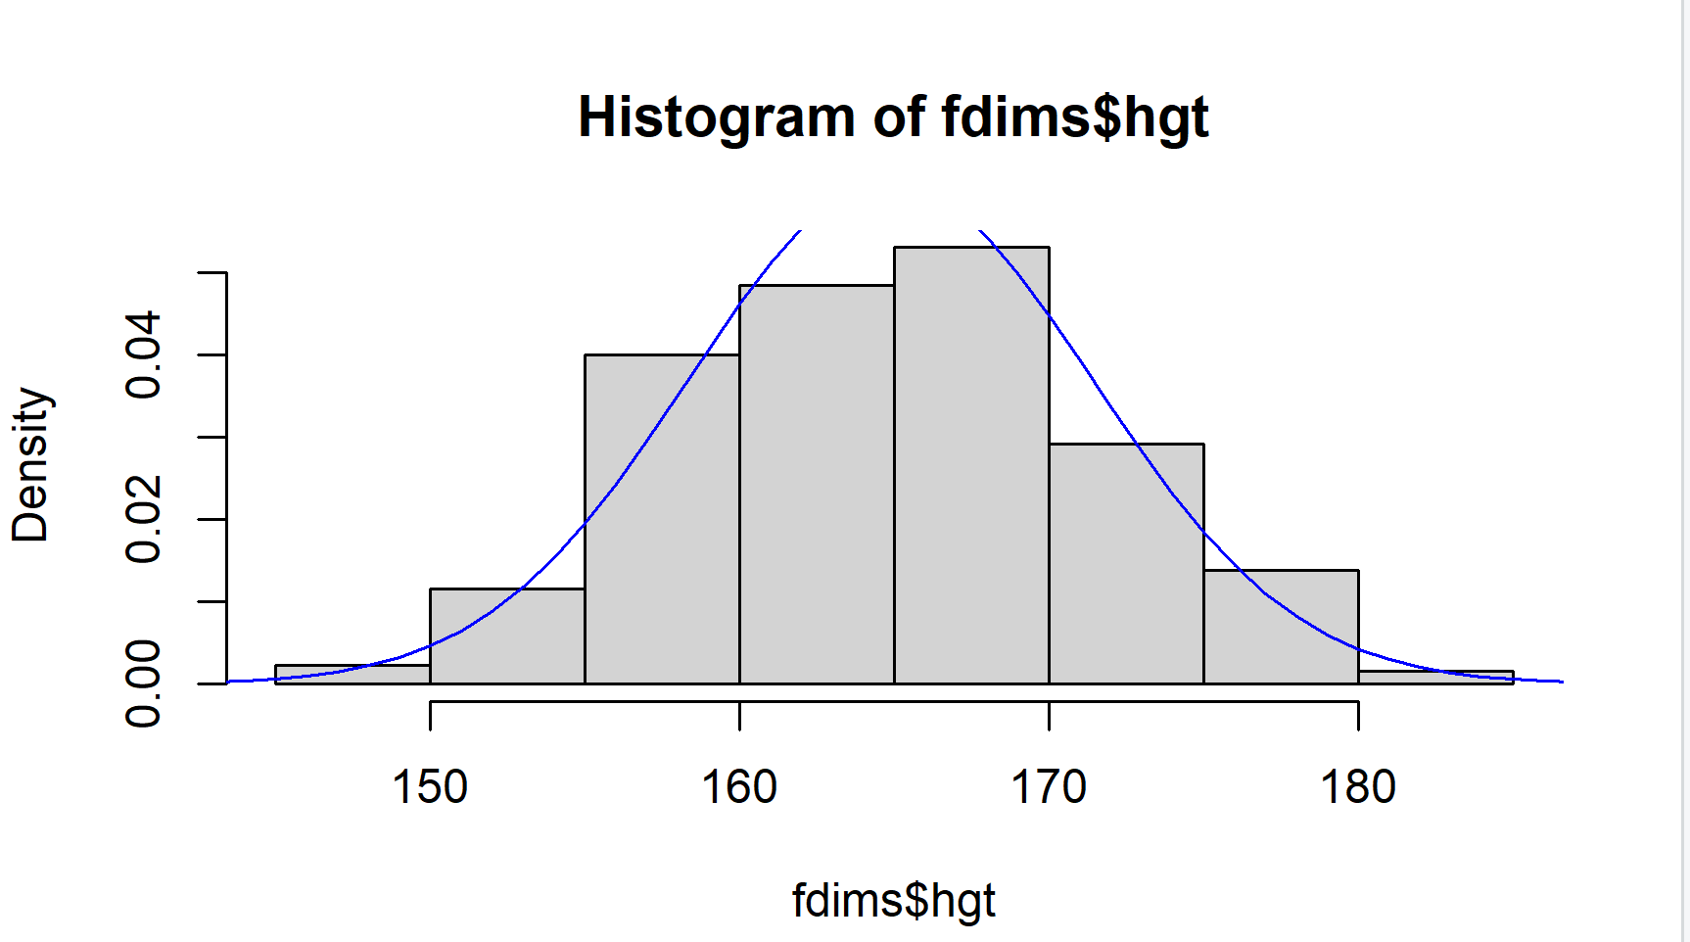
Based on this histogram with a bell-shaped curve, it looks like it is a normal distribution for data of women’s heights.

Exercise 3: Make a normal probability plot of sim_norm. Do all of the points fall on the line? How does this plot compare to the probability plot for the real data? (Include both plots.)
The normal probability plot of sim_norm:
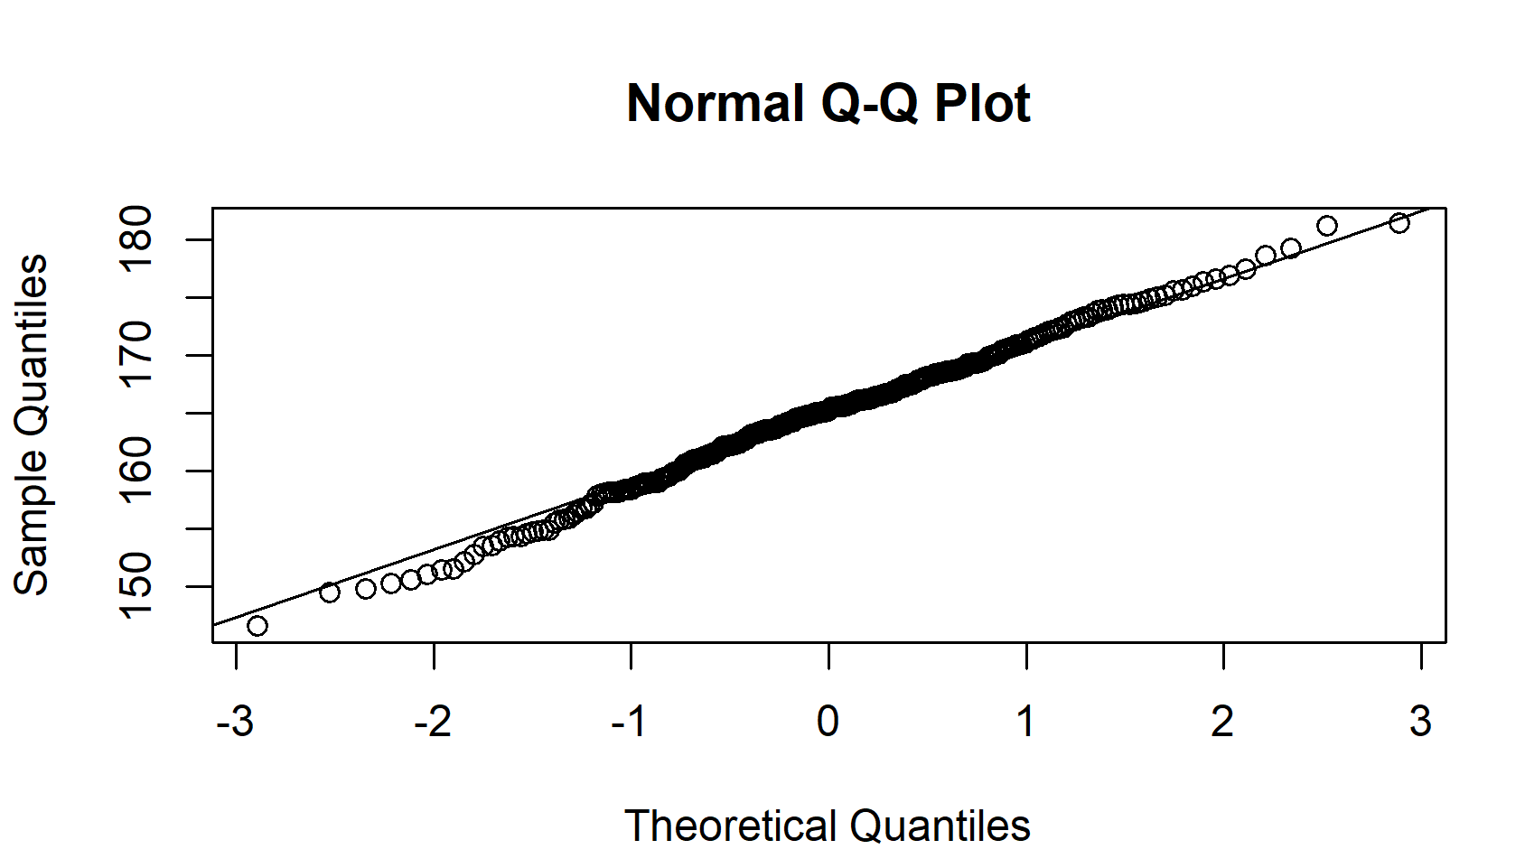
A data set that is nearly normal will result in a probability plot where the points closely follow the line. Except for the beginning and the end, the points closely follow the line.
The probability plot for the real data:
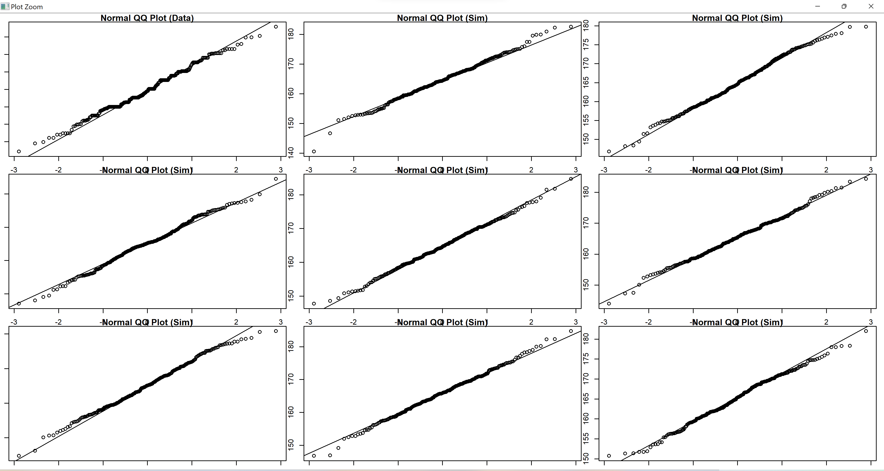
The probability plot for sim_norm and the real data are similar. The points on all plots closely follow the line but not the beginning and the tail end.

Exercise 4: Does the normal probability plot for fdims$hgt look similar to the plots created for the simulated data? That is, do plots provide evidence that the female heights are nearly normal? (Include plots.)

The normal probability plot for fdims$hgt:

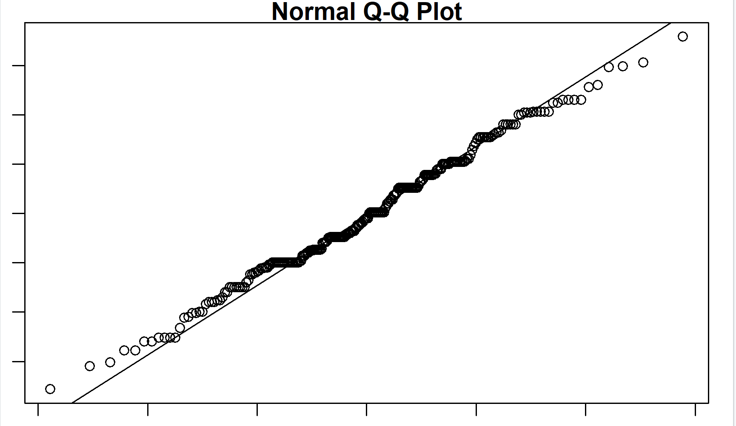
The normal probability plot for fdims$hgt looks similar to the plots created for the simulated data above. This implies that the female heights are nearly normal.

Exercise 5: Using the same techniques from Exercises 2-4, determine whether or not female weights appear to come from a normal distribution. (Include all plots.)

Histogram of female’s weights:
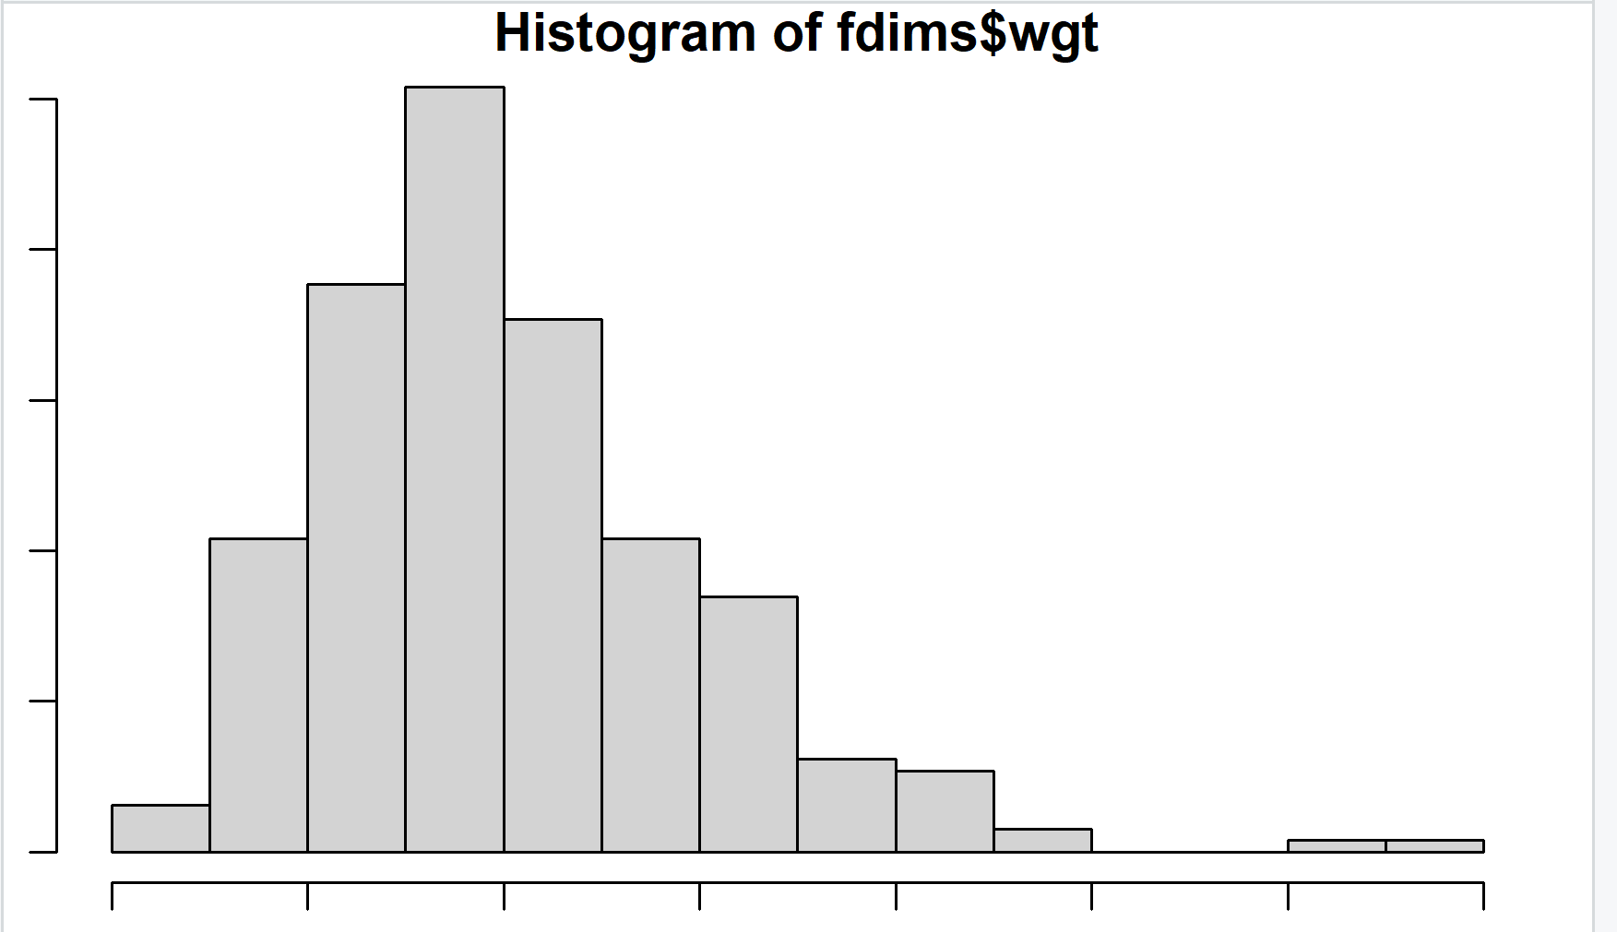

The normal probability plot for female’s weights:
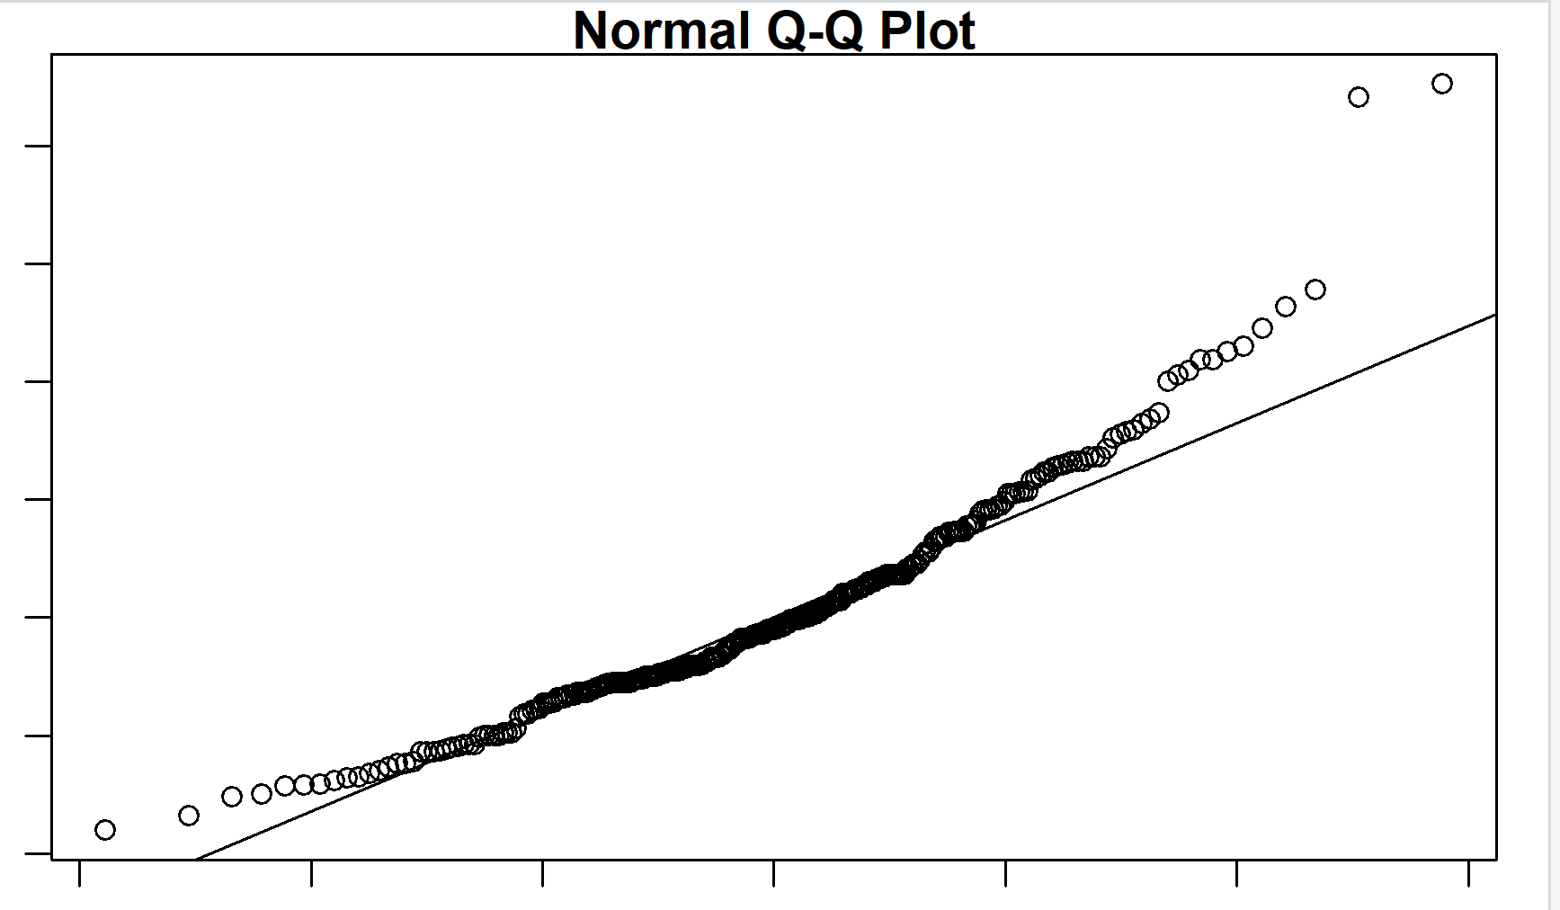
The plot of sim_norm of weights:
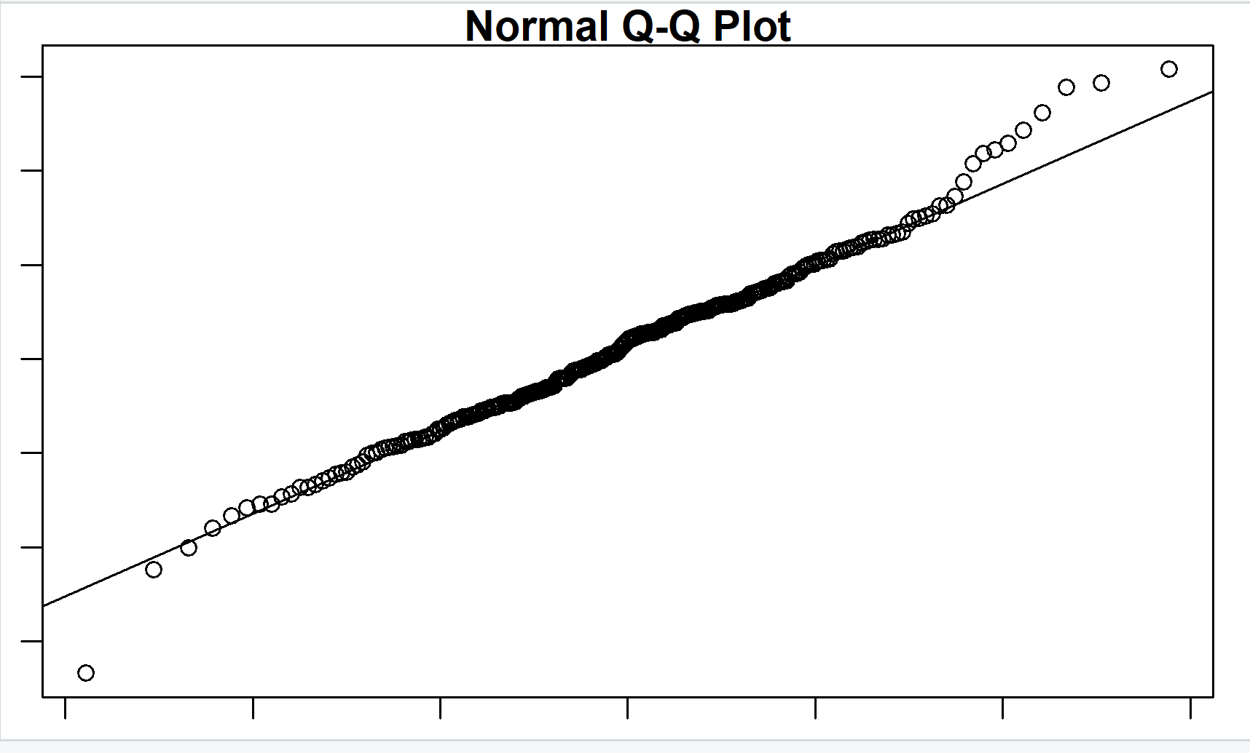
The probability plot for the real data:
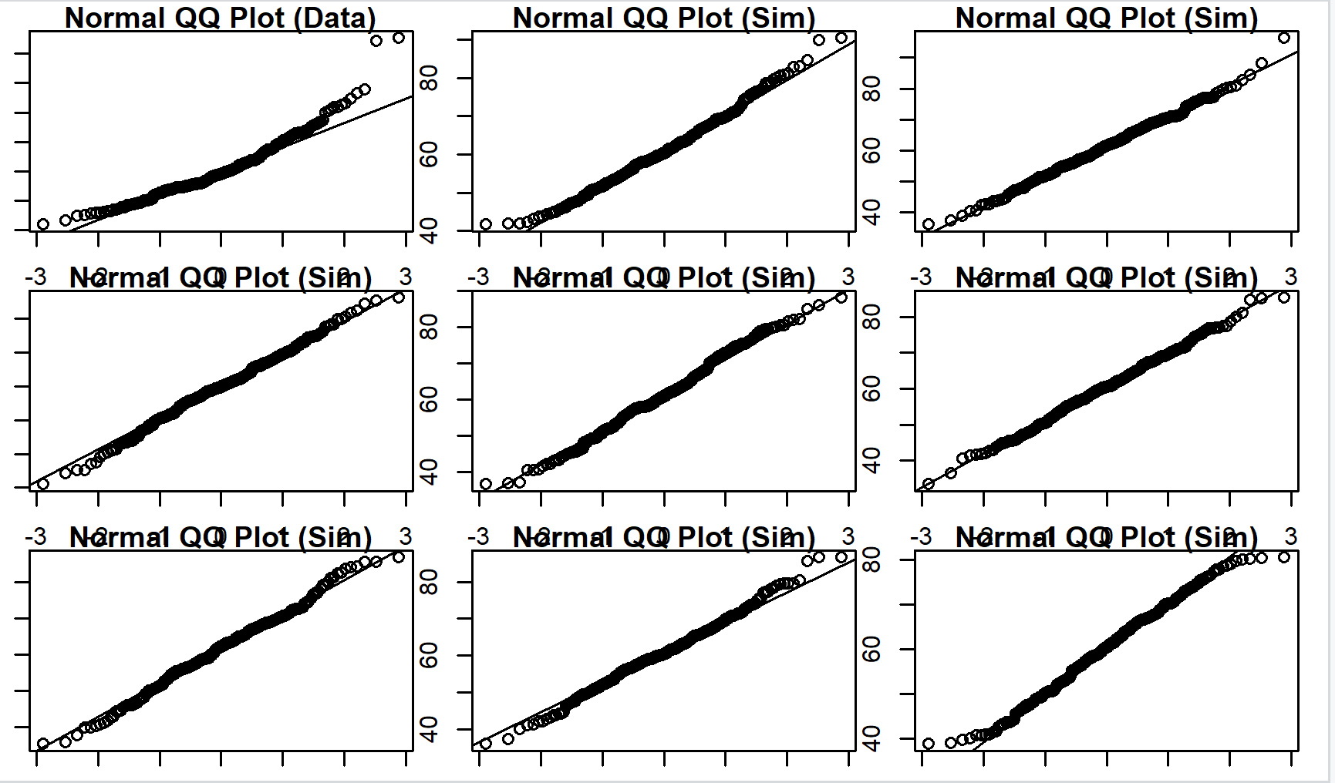
The plots do not indicate a normal distribution. In fact, the data is skewed to the left.
Exercise 6:
- Write out two probability questions that you would like to answer; one regarding female heights and one regarding female weights.
Female heights:
Question: What is the probability that a randomly chosen young adult female is shorter than 158 cm?
Female weights:
Question: What is the probability that a randomly chosen young adult female is heavier than 75kg?
- Calculate the answers to those probabilities using the theoretical normal distribution. Show work.
For heights:
For weights:

- Calculate the answers to those probabilities using the empirical distribution (the data given). Provide code.
For heights:
For weights:
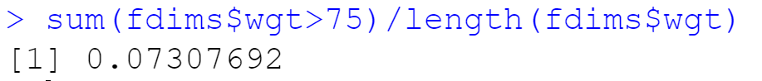
- Which variable, height or weight, had a closer agreement between the two methods?
We can see that height has a closer agreement between the two methods.

On Your Own:
1) Now let’s consider some of the other variables in the body dimensions data set. Using the figures at the end of the exercises, match the histogram to its normal probability plot. All of the variables have been standardized (first subtract the mean, then divide by the standard deviation), so the units won’t be of any help. If you are uncertain based on these figures, generate the plots in R to check.
a. The histogram for female biiliac (pelvic) diameter (bii.di) belongs to normal probability plot letter B.
b. The histogram for female elbow diameter (elb.di) belongs to normal probability plot letter C.
c. The histogram for general age (age) belongs to normal probability plot letter D.
d. The histogram for female chest depth (che.de) belongs to normal probability plot letter A.
(See below.)
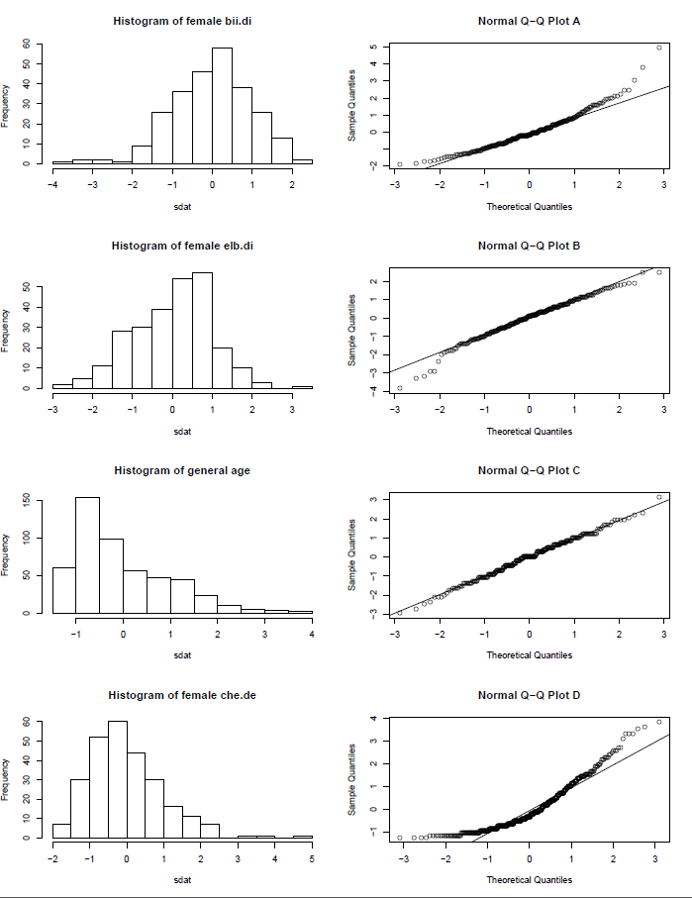

2) Note that normal probability plots C and D have a slight stepwise pattern. Why do you think this is the case?
Elbow diameters for females:
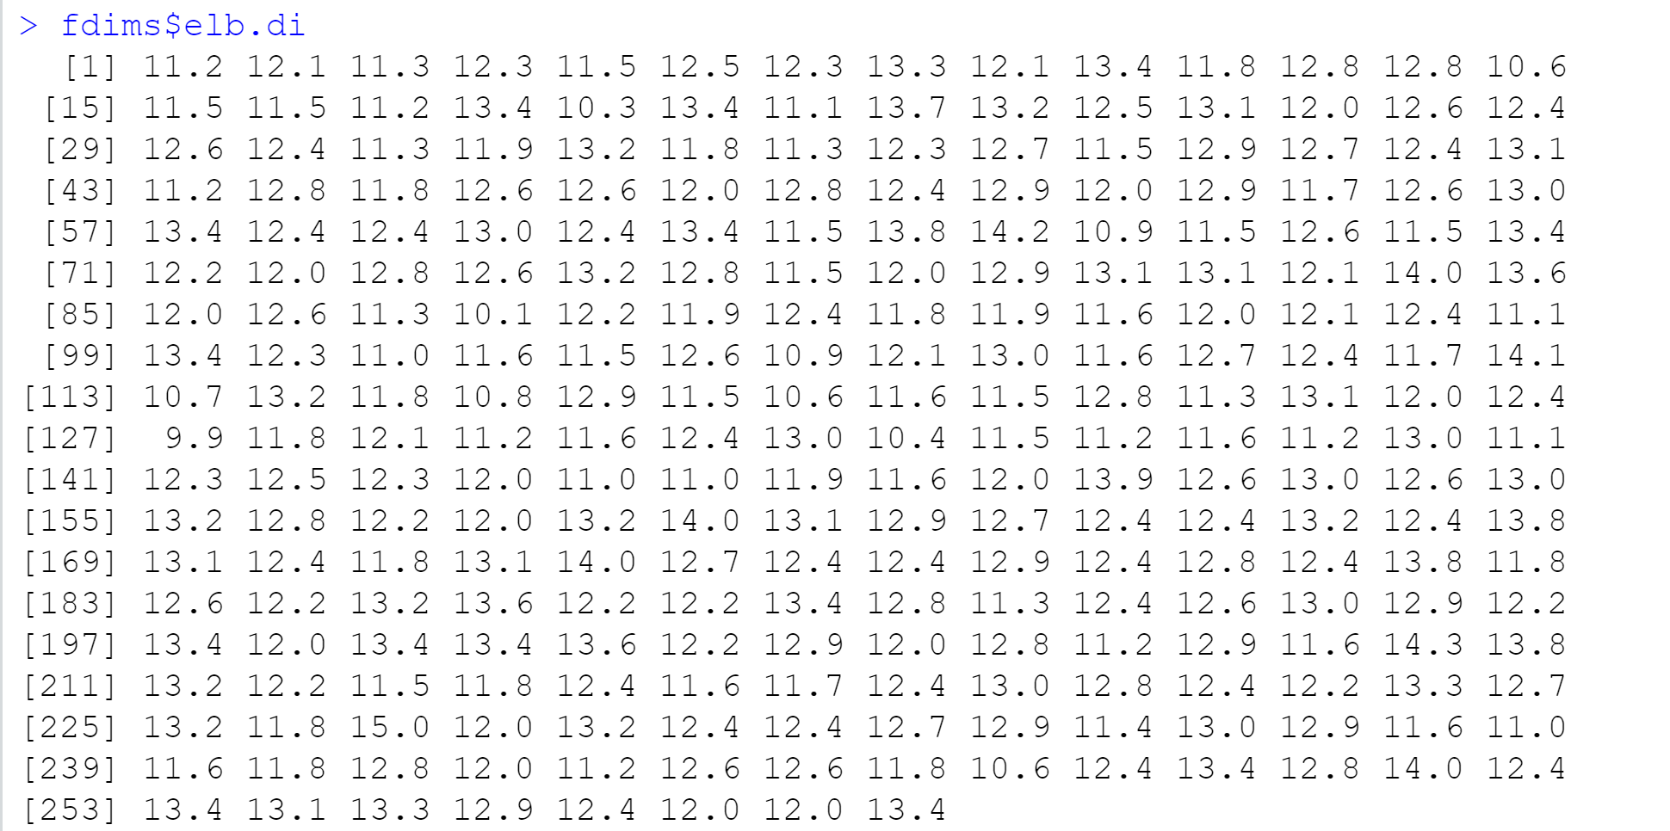

Age for females:
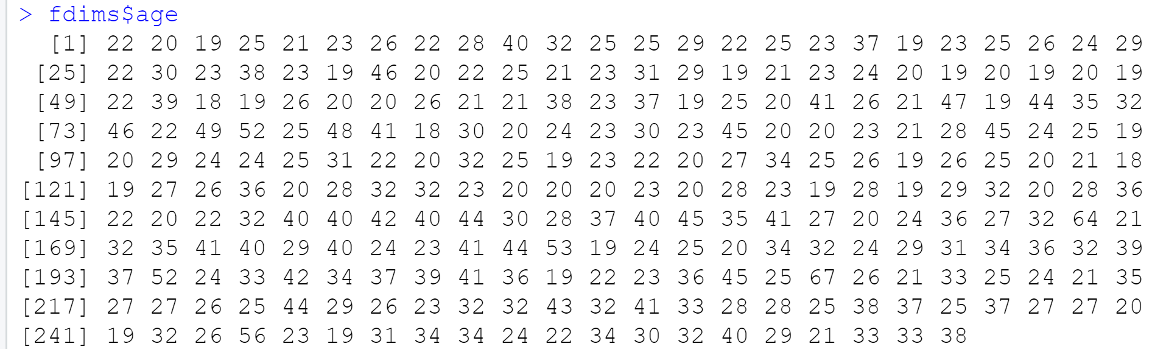
Age is measured in integers while elbow diameters are measured in real numbers. This may cause the slight stepwise pattern in the plots.

3) As you can see, normal probability plots can be used both to assess normality and visualize skewness. Make a normal probability plot for female knee diameter (kne.di). Based on this normal probability plot, is this variable left skewed, symmetric, or right skewed? Use a histogram to confirm your findings. (Include all plots.)

Histogram for female knee diameter (kne.di):
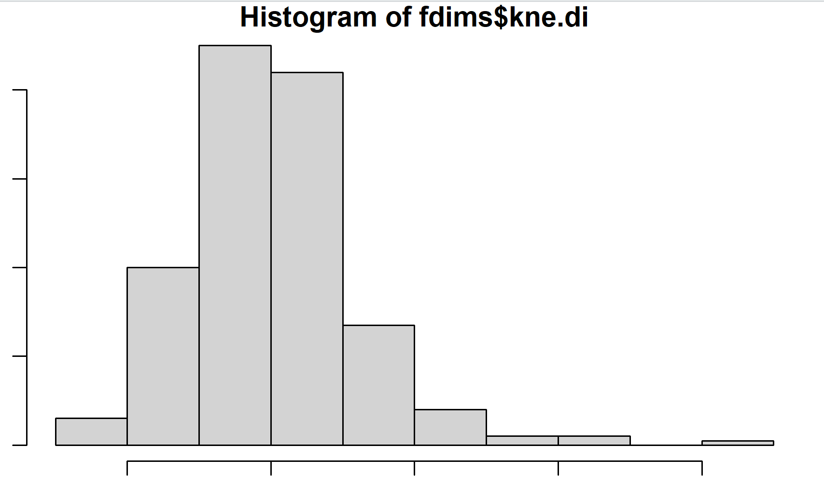
Normal probability plot of female knee diameters:
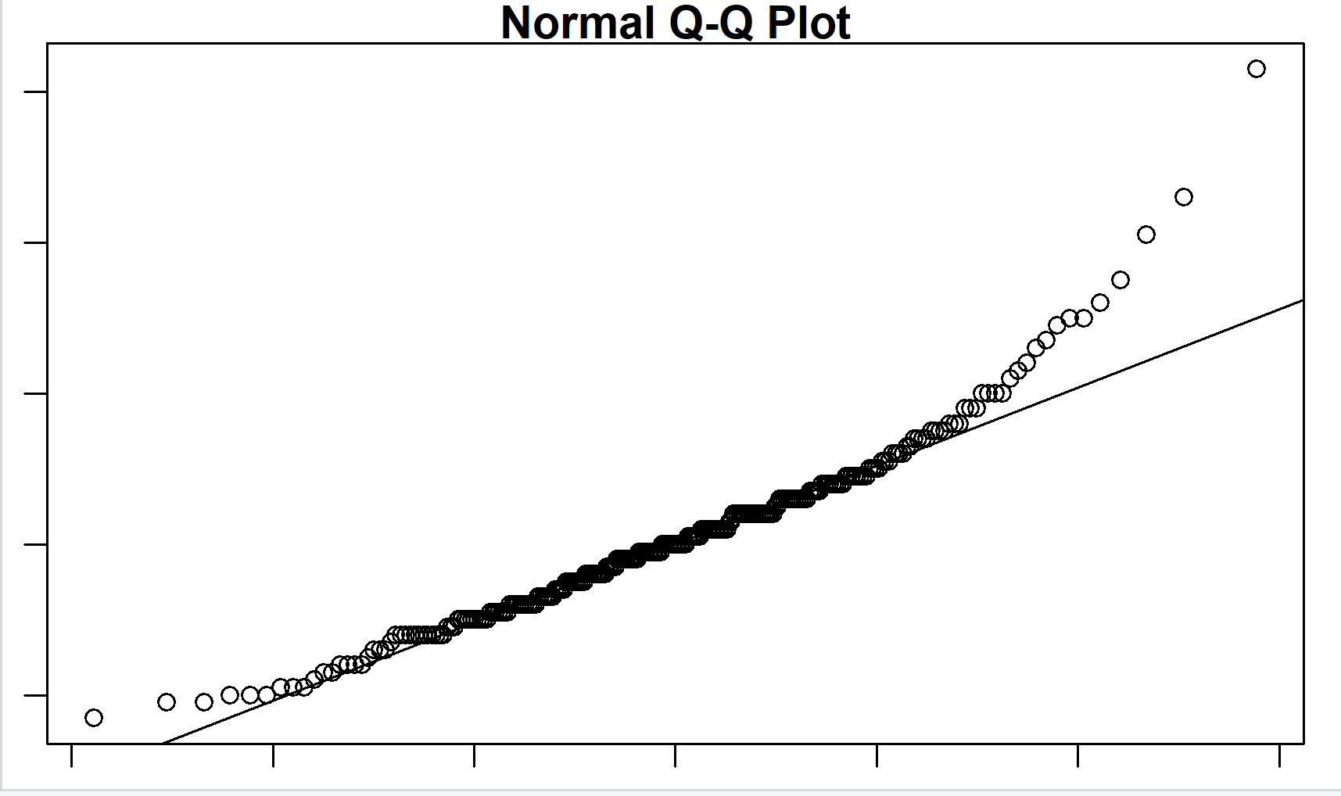
The histogram and the plot show that the data on female knee diameters is right-skewed.

